A Project Report for Artificial Intelligence Lab(22CS605PC) On
AI Career Intelligence Platform using Machine Learning

Submitted to
CMR Technical Campus, Hyderabad
In Partial fulfillment of the requirements for the award of the Degree of
BACHELOR OF TECHNOLOGY
in
COMPUTER SCIENCE & ENGINEERING
by
SINGARAJU SIVA KOTESH
(237R1A05Q1)

Under the esteemed guidance of
Ms. A Divya Bharathi

Assistant Professor

DEPARTMENT OF COMPUTER SCIENCE & ENGINEERING CMR TECHNICAL CAMPUS
An UGC Autonomous Institute
Accredited by NBA & NAAC with A Grade (Approved by AICTE, Affiliated to JNTU, Hyderabad)
Kandlakoya (V), Medchal (M), Hyderabad-501 401
(2025-2026)



CERTIFICATE

This is to certify that the Presentation entitled “AI career intelligence platform using machine learning” is submitted by SINGARAJU SIVA KOTESH bearing the Roll Number 237R1A05Q1 of B.Tech Computer Science and Engineering, In Partial fulfillment of the requirement of the Presentation and for the award of the Degree of Bachelor of Technology during the academic year 2025-26.

Subject Faculty
Ms. A Divya Bharathi Assistant Professor

Institute Vision:
- To Impart quality education in serene atmosphere thus strive for excellence in Technology and Research.
Institute Mission:
- To Create state of art facilities for effective Teaching- Learning Process.
- Pursue and Disseminate Knowledge based research to meet the needs of Industry & Society.
- Infuse Professional, Ethical and Societal values among Learning Community.

Department Vision:
  - To Provide quality education and a conducive learning environment in computer engineering that foster critical thinking, creativity, and practical problem-solving skills.
Department Mission:
  - M1: To educate the students in fundamental principles of computing and induce the skills needed to solve practical problems.
  - M2: To provide State-of-the-art computing laboratory facilities to promote industry-institute interaction to enhance student’s practical knowledge.
  - M3: To Inculcate self-learning abilities, team spirit, and professional ethics among the students to serve society.

CMR TECHNICAL CAMPUS


UGC AUTONOMOUS

Accredited by NBA & NAAC with ‘A’ Grade
Approved by AICTE, New Delhi, and JNTU Hyderabad

Academic Year Name of the Student Roll No  Year Semester Section Branch  Name of the Laboratory Batch No  Title of the Lab Report/Project  Date  Signature of the Student | : 2025-2026  : SINGARAJU SIVA KOTESH  : 237R1A05Q1  : B. Tech III  : II  : D  : COMPUTER SCIENCE & ENGINEERING  : ARTIFICIAL INTELLIGENCE  : 5  : AI CAREER INTELLIGENCE PLATFORM USING  MACHINE LEARNING  : 25/3/2026  : SINGARAJU SIVA KOTESH

LABORATORY REPORT/PROJECT & PRESENTATION
Problem Statement &  Objectives | Design & Methodology | Implementation  & Results | Total Marks | Final Marks
10 | 15 | 15 | 40 | 10
Remarks/Comments by the Faculty:
Name of the Faculty : Ms. A Divya Bharathi Signature of the Faculty :

TABLE OF CONTENTS:
- ABSTRACT 6
- INTRODUCTION 7
- PURPOSE 8
- OBJECTIVES 8
- USER INSTRUCTIONS 9-10
- SAMPLE CODE 11-15
- OUTPUT 16
- FUTURE IMPROVEMENTS 17
- CONCLUSION 17
- REFERENCES 18

ABSTRACT

This project focuses on developing an AI-based Career Intelligence Platform using Machine Learning techniques. The system helps users make better career decisions by analyzing their skills, interests, and academic performance.
Machine Learning algorithms are used to recommend suitable career paths, job roles, and required skill sets. The platform collects user data, processes it, and provides intelligent suggestions based on patterns learned from datasets.
The system aims to bridge the gap between education and employment by guiding students and job seekers toward the most suitable career opportunities.

INTRODUCTION

Choosing the right career path is one of the most important decisions in a person's life. Many students lack proper guidance and awareness about career opportunities available in different domains.
With the advancement of Artificial Intelligence and Machine Learning, it is possible to build systems that analyze user data and provide personalized career recommendations.
The AI Career Intelligence Platform uses Machine Learning models to understand user profiles and suggest relevant career options. It helps users identify their strengths, required skills, and potential job roles
.

PURPOSE

The main purpose of this project is to develop an intelligent system that:
- Provides career recommendations based on user input
- Analyzes skills, interests, and academic performance
- Suggests suitable job roles and career paths
- Helps users understand required skills for specific careers
- Bridges the gap between students and industry demands

OBJECTIVES

- To understand the role of Machine Learning in career guidance
- To build a recommendation system for career paths
- To analyze user data effectively
- To provide personalized suggestions
- To improve decision-making for students and job seekers

USER INSTRUCTIONS

Step 1: Install Required Libraries
pip install numpy pandas scikit-learn
Step 2: Prepare Files
- Create project folder
- Save Python file (main.py)
Step 3: Run Program
python main.py
Step 4: Enter Details
- Input skills and interests
Step 5: View Results
- System displays career suggestions

SAMPLE CODE

import streamlit as st
import pandas as pd
import numpy as np
from sklearn.ensemble import RandomForestClassifier
from sklearn.linear_model import LogisticRegression
from sklearn.tree import DecisionTreeClassifier
from sklearn.metrics import accuracy_score
import plotly.graph_objects as go
import plotly.express as px
import PyPDF2

st.set_page_config(page_title="AI Career Intelligence", layout="wide")

# ---------- THEME ----------
st.markdown("""
<style>
.stApp {background: linear-gradient(180deg,#000,#0a0a0a); color:white;}
h1,h2,h3 {color:#ffb6c1;}
section[data-testid="stSidebar"] {background:#000;}
.block-container {padding-top:2rem;}
</style>
""", unsafe_allow_html=True)

st.title("🚀 AI Career Intelligence Platform")

page = st.sidebar.radio(
"Navigation",
["📊 Dashboard","🎯 Placement","💼 Role Predictor",
"📄 Resume AI","🔗 LinkedIn Analyzer","📈 Model Analytics"]
)

# ---------- DATASET ----------
data = {
"cgpa":[5,6,7,8,9,7,6,8,9,5,7,8],
"technical":[30,40,50,60,70,55,45,65,75,35,80,85],
"communication":[35,45,55,65,75,60,50,70,80,40,75,85],
"internships":[0,1,1,2,3,1,2,3,4,0,2,3],
"talent_score":[20,30,40,50,60,45,35,55,65,25,70,80],
"placed":[0,0,1,1,1,1,0,1,1,0,1,1],
"role":[0,1,2,3,4,2,1,3,4,0,5,5]
}

df = pd.DataFrame(data)

X = df[["cgpa","technical","communication","internships","talent_score"]]
y_place = df["placed"]
y_role = df["role"]

rf = RandomForestClassifier().fit(X,y_place)
lr = LogisticRegression().fit(X,y_place)
dt = DecisionTreeClassifier().fit(X,y_place)

role_model = RandomForestClassifier().fit(X,y_role)

role_map = {
0:"Manual Tester",
1:"Software Developer",
2:"Web Developer",
3:"Data Analyst",
4:"Data Scientist",
5:"ML Engineer"
}

# ================= DASHBOARD =================
if page == "📊 Dashboard":

st.header("Career Analytics Overview")

c1,c2,c3,c4 = st.columns(4)
c1.metric("Students",len(df))
c2.metric("Placement Rate",str(int(df["placed"].mean()*100))+"%")
c3.metric("Avg Internships",round(df["internships"].mean(),1))
c4.metric("Avg Talent Score",round(df["talent_score"].mean(),1))

st.bar_chart(df[["technical","communication","talent_score"]])

# ================= PLACEMENT =================
elif page == " Placement":

st.header("AI Placement Prediction")

cgpa = st.slider("CGPA",0.0,10.0,7.0)
tech = st.slider("Technical Skill",0,100,60)
comm = st.slider("Communication",0,100,60)
interns = st.slider("Internships",0,6,1)
talent = st.slider("Extra Talent",0,100,50)

radar_df = pd.DataFrame({
"Skill":["Technical","Communication","Talent"],
"Score":[tech,comm,talent]
})

radar = px.line_polar(
radar_df,r="Score",theta="Skill",
line_close=True,color_discrete_sequence=["#ff69b4"]
)
radar.update_traces(fill='toself')
st.plotly_chart(radar,width='stretch')

if st.button("Predict Placement"):

inp = np.array([[cgpa,tech,comm,interns,talent]])
prob = rf.predict_proba(inp)[0][1]*100

gauge = go.Figure(go.Indicator(
mode="gauge+number",
value=prob,
title={'text':"Placement Probability"},
gauge={'axis':{'range':[0,100]},
'bar':{'color':"#ff69b4"}}
))
st.plotly_chart(gauge,width='stretch')

# ================= ROLE =================
elif page == "💼 Role Predictor":

st.header("AI Career Role Recommendation")

cgpa = st.slider("CGPA",0.0,10.0,7.0,key=1)
tech = st.slider("Technical",0,100,60,key=2)
comm = st.slider("Communication",0,100,60,key=3)
interns = st.slider("Internships",0,6,1,key=4)
talent = st.slider("Talent Score",0,100,50,key=5)

if st.button("Predict Role"):

inp = np.array([[cgpa,tech,comm,interns,talent]])
role = role_model.predict(inp)[0]

st.success(f"🎯 Best Career Role: {role_map[role]}")

# ================= RESUME =================
elif page == "📄 Resume AI":

st.header("AI Resume Analyzer")

file = st.file_uploader("Upload Resume PDF",type=["pdf"])

if file:

text = ""
reader = PyPDF2.PdfReader(file)

for p in reader.pages:
t = p.extract_text()
if t:
text += t

text = text.lower()
score = 40

if "python" in text: score+=10
if "machine learning" in text: score+=15
if "sql" in text: score+=10
if "java" in text: score+=10
if "project" in text: score+=10

gauge = go.Figure(go.Indicator(
mode="gauge+number",
value=score,
title={'text':"Resume Strength"},
gauge={'axis':{'range':[0,100]},
'bar':{'color':"#ffb6c1"}}
))

st.plotly_chart(gauge,width='stretch')

# ================= LINKEDIN =================
elif page == "🔗 LinkedIn Analyzer":

st.header("LinkedIn Profile Analyzer")

bio = st.text_area("Paste LinkedIn About Section")

if st.button("Analyze Profile"):

score = 50
bio = bio.lower()

if "ai" in bio: score+=10
if "machine learning" in bio: score+=10
if "leadership" in bio: score+=10
if "project" in bio: score+=10
if "internship" in bio: score+=10

st.success(f"LinkedIn Strength Score: {score}")

# ================= MODEL =================
elif page == "📈 Model Analytics":

st.header("Model Accuracy Comparison")

rf_acc = accuracy_score(y_place, rf.predict(X))
lr_acc = accuracy_score(y_place, lr.predict(X))
dt_acc = accuracy_score(y_place, dt.predict(X))

acc_df = pd.DataFrame({
"Model":["RandomForest","Logistic","DecisionTree"],
"Accuracy":[rf_acc,lr_acc,dt_acc]
})

fig = px.bar(
acc_df,
x="Model",
y="Accuracy",
color_discrete_sequence=["#ff69b4"]
)

st.plotly_chart(fig,width='stretch')

OUTPUT

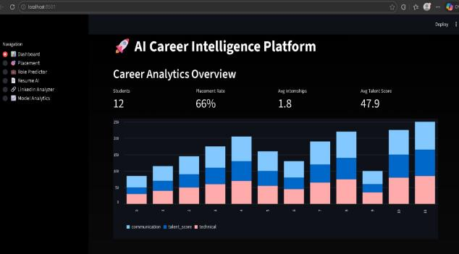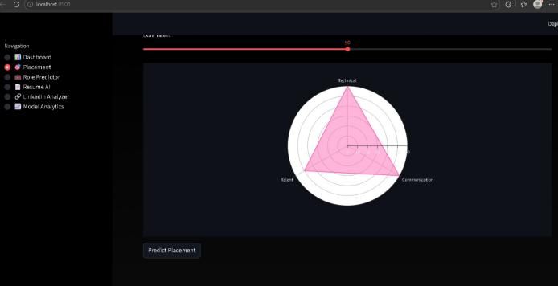

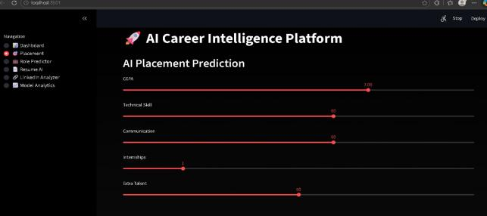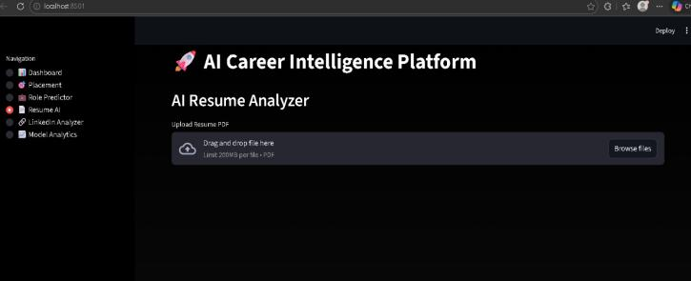

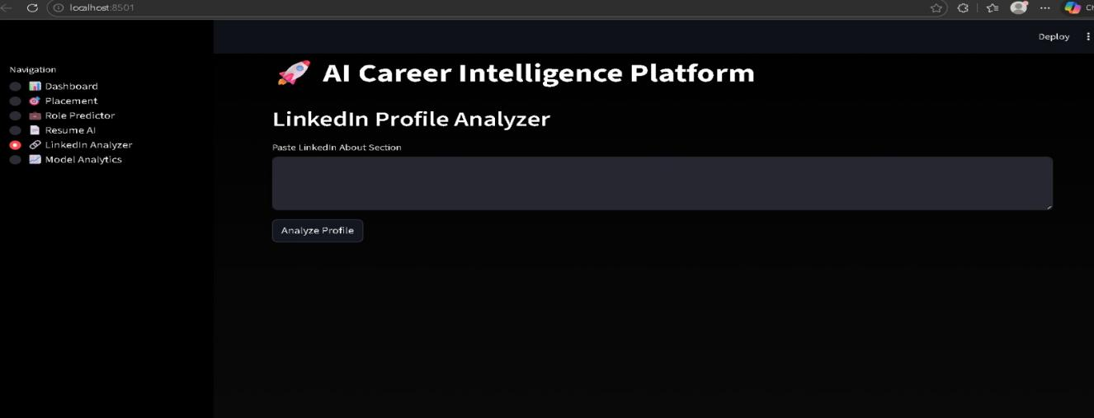

FUTURE IMPROVEMENTS

Add real-time job market data

Integrate with LinkedIn APIs

Build web or mobile application

Improve accuracy using deep learning

Add personality-based recommendation

CONCLUSION

This project demonstrates how Machine Learning can be used to guide individuals in choosing the right career path. The AI Career Intelligence Platform provides personalized recommendations based on user data, helping students and job seekers make informed decisions.
The system can be further enhanced to become a powerful tool for career planning and development.

REFERENCES

- Python Documentation – https://docs.python.org
- Scikit-learn Documentation – https://scikit-learn.org
- Machine Learning Basics – Various online resources
- Scikit-learn Official Documentation – https://scikit-learn.org/stable/index.html
(Provides tools for classification, regression, clustering, and model evaluation)
- GeeksforGeeks Machine Learning Tutorial – https://www.geeksforgeeks.org/machine-learning/

